Name | Siddhesh Sonar
UID no. | 2021700063
Experiment No. | 10

AIM: | To implement Robin Karp algorithm
Program
PROBLEM STATEMENT : | To implement Robin Karp algorithm
ALGORITHM/  THEORY: | The Rabin-Karp string matching algorithm calculates a hash value for the pattern, as well as for each M-character subsequences of text to be compared. If the hash values are unequal, the algorithm will determine the hash value for next M-character sequence. If the hash values are equal, the algorithm will analyze the pattern and the M-character sequence. In this way, there is only one comparison per text subsequence, and character matching is only required when the hash values match.  Algorithm:  RABIN-KARP-MATCHER (T, P, d, q)  1. n ← length [T]  2. m ← length [P]  3. h ← dm-1 mod q  4. p ← 0  5. t0 ← 0  6. for i ← 1 to m  7. do p ← (dp + P[i]) mod q  8. t0 ← (dt0+T [i]) mod q  9. for s ← 0 to n-m  10. do if p = ts  11. then if P [1.....m] = T [s+1.....s + m]  12. then "Pattern occurs with shift" s  13. If s < n-m  14. then ts+1 ← (d (ts-T [s+1]h)+T [s+m+1])mod q
PROGRAM: | #include <stdio.h>  #include <string.h>  void search(char pat[], char txt[], int q)  {  int M = strlen(pat);  int N = strlen(txt);  int p = 0, t = 0, h = 1, d = 256;  int i, j;  for (i = 0; i < M - 1; i++) {  h = (h * d) % q;  }  for (i = 0; i < M; i++) {  p = (d * p + pat[i]) % q;  t = (d * t + txt[i]) % q;  }  for (i = 0; i <= N - M; i++) {  if (p == t) {  for (j = 0; j < M; j++) {  if (txt[i + j] != pat[j]) {  break;  }  }  if (j == M) {  printf("\nPattern found at index %d \n", i);  }  }  if (i < N - M) {  t = (d * (t - txt[i] * h) + txt[i + M]) % q;  if (t < 0) {  t = (t + q);  }  }  }  }  int main()  {  char txt[100], pat[100];  printf("\nEnter the text: ");  scanf("%[^\n]s",txt);  getchar();  printf("\nEnter the pattern: ");  scanf("%[^\n]s",pat);  int q = 101;  search(pat, txt, q);  return 0;  }
RESULT:

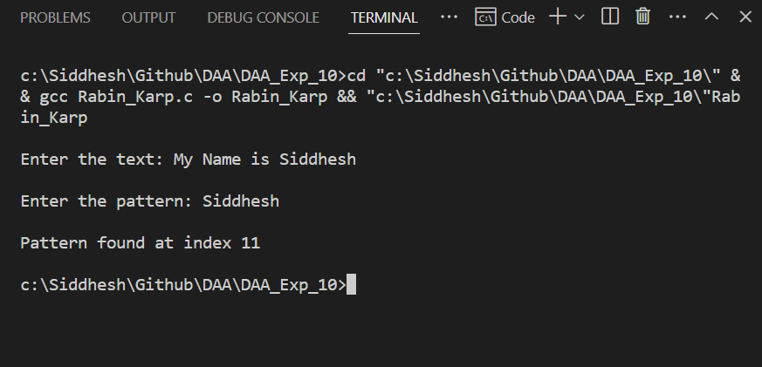

CONCLUSION: | Successfully understood Rabin Karp algorithm and implemented it in C program to match strings.

